8th Street Bridge on track to be completed by Thanksgiving
- By McKENNA HORSLEY mhorsley@hdmediallc.com
Sunday, Front Page, Sep 26, 2021
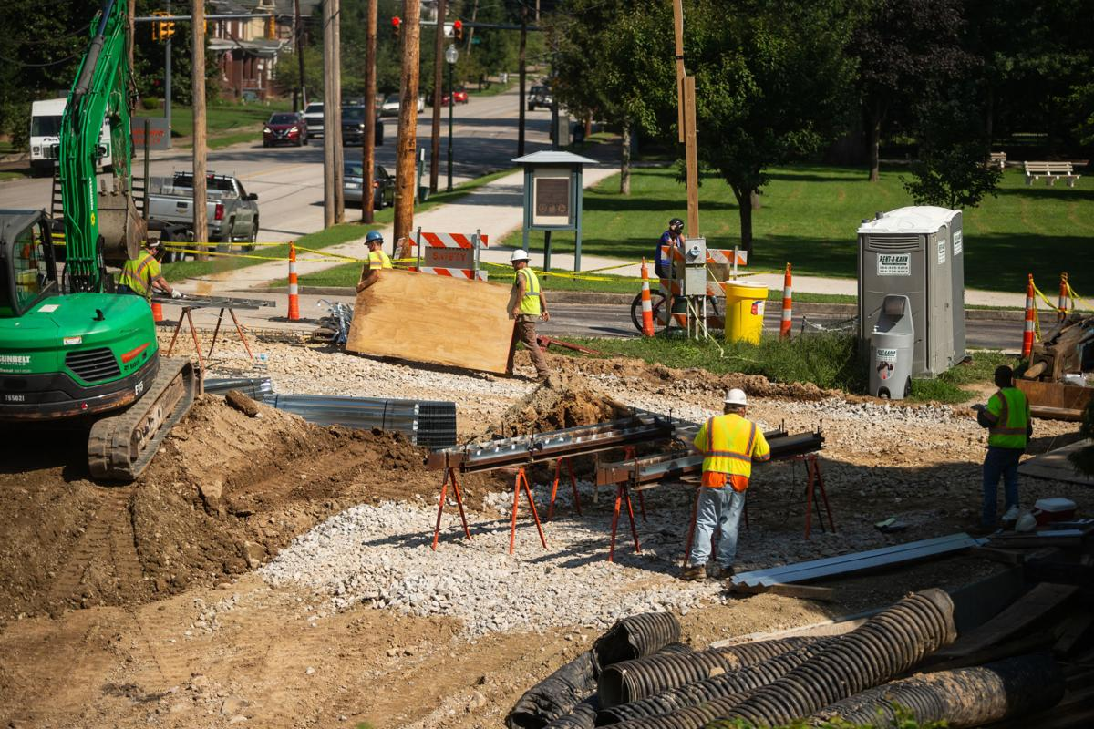

Construction crews work on a project to replace the 8th Street Bridge near Ritter Park on Aug. 23, 2021, in Huntington. Ryan Fischer | The Herald-Dispatch

HUNTINGTON — The 8th Street Bridge is expected to be replaced by Thanksgiving.
The replacement is one of two in Huntington’s Southside. Work began on the bridge in June. The next bridge to be replaced will be the 5th Street Bridge.
“Everything is going according to schedule,” said Rob Pennington, District 2 manager for the West Virginia Division of Highways.
Workers have recently placed the bridge decks and will pour concrete for the bridge ends soon, he said. After the 8th Street Bridge work is completed, work will begin on the 5th Street Bridge.
Through work with the Southside Preservation and Enhancement Alliance, period-specific lighting will be added to the bridges, Pennington said.
Lighting will go under the bridges and concrete pedestals with light fixtures on top will be on the corners of the bridges.
Dan Gooding, the president of the Alliance, wrote in an email that the light fixtures would “add lamp posts and globes, similar to the originals, to the ends of each bridge’s balustrade abutments.”
“We are so very thankful for the splendid support of the City, DOH’s Charleston office, DOH District 2 and the State Historic Preservation Office in this effort. They were all very helpful,” he wrote. “These two new bridges are slated to be architectural ornaments to the City of Huntington and its Southside in addition to filling their critical utilitarian transportation roles better than ever!”
The Alliance previously advocated that the replacement bridges reflect the historic styles of the Southside bridges. Gooding said in an email that the group’s Bridge Committee was unaware of the original lamp posts on the 8th Street Bridge until a photo of the fixtures was found in a Marshall University yearbook. He said the photo predated the bridges’ mid-life remodeling. After the discovery, the group asked if the light fixtures could be added to the project.
The drawings were made with aid from Bridge Committee Chairman and Marathon civil engineer Alan Caudill and Steve Matthews at State Electric.
According to letters provided by Gooding, the cost of adding light posts is $75,000 and the city of Huntington has agreed to pay 20% of this cost, as it is in a cost share agreement with the state on the project.
The plan is to not fully close 5th Street to traffic, like 8th Street has been, Pennington said. A structure will be added on the west side of the 5th Street Bridge with room for two lanes of traffic, and then work will begin on the existing bridge. By the end of the project, the new bridge will combine both halves together, making a wider bridge at 5th Street. The new bridge will have three lanes, with the middle being a turning lane, Pennington said.
Work at the 5th Street Bridge is expected to be complete by August 2022, Pennington said. The project will be weather-dependent, he added.
If the upcoming winter is moderate and mild, the project should remain on schedule.
The West Virginia Department of Transportation announced the $3.7 million project to replace both bridges in 2017.
McKenna Horsley is a reporter for The Herald-Dispatch, covering local government in Huntington and Cabell County. Follow her on Twitter @Mckennahorsley.

