HERALD-DISPATCH, JUNE 16TH, FRONT-PAGE
BRIDGE WORK
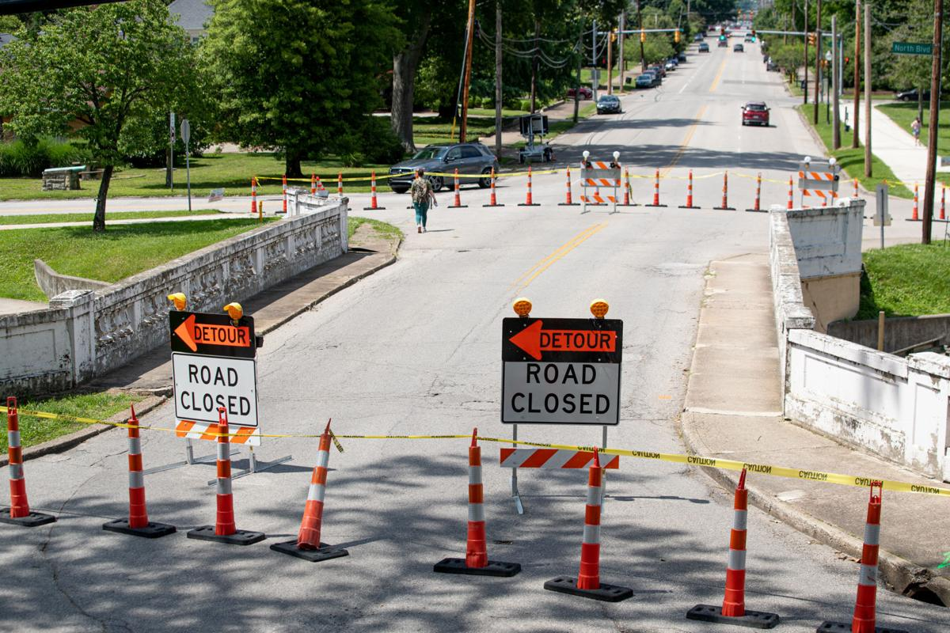

8TH STREET BRIDGE CLOSES AHEAD OF DEMOLITION, REPLACEMENT

HUNTINGTON — The 8th Street Bridge near Ritter Park in Huntington was closed to traffic Tuesday. In preparation for a project to demolish and replace the old structure. The 8th Street Bridge will likely be closed through the end of this year. The contract for the project also includes work on the 5th Street Bridge, but the work on the travel lanes at that bridge won’t begin until 8th Street is completed. Crews close the 8th Street Bridge near Ritter Park on Tuesday, June 15, 2021, in Huntington. The demolition and replacement project of the bridge is set to start this week. The West Virginia Department of Transportation announced the $3.7 million project to replace both bridges in 2017. Earlier this year, the Southside Preservation and Enhancement Alliance approved final designs for the 5th Street and 8th Street bridges. The new designs differ from the original proposals in that they reflect the historic appearance of the bridges, which date back to the 1920s.
Please Note: Boldface type was added by our webmaster for emphasis.

